**CSE 299: Junior Design Course**

**Project Proposal**

Parking Space Sharing App

Section [9/10]

Team Number: 10

Team member

Raktim Raihan Prova – 1530600642

ASM Rayhan - 1530080042

Faqrul Hasan Arif –

Dibya Jyoti Dhar - 1530922042

Submission Date:

9 October 2018



Department of Electrical and Computer Engineering

North South University

Fall 2018

Background:

The sight of cars being jacked and locked on the streets of Dhaka city has emerged as an everyday phenomenon. Any person roaming inside the city must have experienced this spectacle in recent days. This incident takes place when the car owners or the drivers park them at unauthorized or inappropriate places. Undoubtedly, it has become an absolute necessity that these cars should be parked properly at proper places. But are there enough suitable places for parking cars in the city?

The Dhaka city corporations and the metropolitan police have selected **42 on-street** parking spots to tackle the growing traffic congestion in the capital, one of most densely populated cities in the world. About 2,000 vehicles can be parked at a time in these spots, selected on trial basis, in Gulshan, Banani, Uttara, Mirpur, New Market, Nilkhet, Palashi, Elephant Road, Motijheel and Balurmath.

With around **17 million** residents, Dhaka currently has around **342,000 private** motorized vehicles, according to Bangladesh Road Transport Authority (BRTA). Of them, **27,396 cars** were registered last year alone.

A 2014 study by Rajuk noted that parking facilities were way too inadequate in the capital. Facilities owned by Rajuk and Dhaka city corporations could accommodate only **1,474 vehicles** in the off-street parking slots.

Illegal parking on the road causes traffic chaos and even congestion, especially in a city like Dhaka, where road space is severely inadequate compared to the demand. Illegal parking on the road makes the traffic situation even worse as it reduces the road capacity even more.

Due to parking of vehicles on the footpath, pedestrians are forced to walk on the road. This causes a serious safety concern for the pedestrians as they risk themselves being hit by oncoming vehicles. In addition, pedestrians walking on the road leads to road capacity being reduced even more, causing traffic chaos and congestion.

Although most people realize and understand that illegal parking on the road or on the footpath causes traffic mayhem, when they go to a place with their vehicle which does not offer any parking space, they have no choice but to park their vehicles illegally on the road or on the footpath

# One of the main reasons of traffic jam is Illegal parking. Dhaka traffic wastes 5 million work hours and costs Tk 37,000 crore a year. With adequate traffic management and efficient public transportation, at least 60% of the losses could be recouped, amounting to Tk 22,200 crore.

# Moreover, there raised a minor problem for this reason along with unorganized parking space which can be marked as the insecurity of the vehicle owner.

# In 2005 Bangladesh motor vehicle theft rate was 0.74 cases per 100,000 population, and in 2006 the rate was about 0.70 cases per 100,000 population which is less than 1.35% than previous year and the total number of vehicle theft in both years is around 1500. Though the data is old but we can justify that the theft rate can’t be ignored. Later in 2009 vehicle tracking system with help of various telecommunication company (like Banglalink, Grameenphone, Robi) is introduced based on GPS tracking system, but the system can’t prevent the theft to be occurred rather it helps to find out the vehicle which has been stolen. In most cases, thieves are smart enough to detach the tracking device that leads to the possibility of never finding the vehicle later.

# Dhaka is a fast-growing city. It is one of the most congested cities in the world. New high-rise developments are sprouting throughout the city quickly. To ensure that traffic in Dhaka does not continue to worsen due to illegal parking, we have to solve this problem.

**Problem statement:**

In summary, Dhaka city can provide with less than 1% parking space for more than 0.3 million vehicle which in the main cause for traffic jam in busy areas as well as residential areas, moreover security issue like: raising thievery over recent years in an exponential rate.

So, it can be said that main problem for inadequate parking space are:

* Reducing Traffic jam and Road accident.
* Ensure security of owners.

**Proposed Solution:**

So, we are offering a solution with a parking space sharing app. People tend to keep their vehicle outside any corporate house or school-colleges where there is not any scope to park. More precisely they park their vehicle blocking an active lane where in most of the roads in Dhaka city has only two lanes. Even Government can’t apply laws to overcome this problem as there is hardly any road having a separate parking lane that can only to be used for parking vehicle at any moment. With existing resources available we proposed this parking space sharing app to overcome this problem.

We hardly have any separate parking lane, but luckily, we have separate parking space in most of the residential buildings. Though these spaces can’t solve the problem wholly, but can improve the current statistics resulting less traffic jam.

Our app will allow user to search for a nearest available parking place where he/she can park his vehicle for hours or even days. The owner of the place will register available parking spaces through the app. Owner will provide information about space availability time and vehicle type to be parked.

So, user/driver searches with the type of vehicle he is driving and gets the contact number of the space owner that matches his need. And owner will charge a minimum amount for letting his driveway renting or sharing. Thus, it solves the problem of parking here and there.

With our proposed App we will address the following issues:

1. The app will provide a low cost, hassle free parking system encouraging people to park in specified parking place.
2. We will focus on most traffic prone areas by assuring more parking space in those places.
3. Security will be one of the most prioritize area while developing the app so that the user can feel safe using the service.
4. We will make sure all the existing traffics laws are being followed when someone becomes a user of the service. Like making sure the driver has a proper license.
5. The cost will be reasonable so that nobody parks in the street thinking that it will cost them a lot to park in a parking spot.

**Impacts:**

* Reduced traffic congestion: Traffic congestion is considered to be one of the biggest problems in a megacity like Dhaka. Thousands of working hours of million people is wasted due to traffic jam. And one reason for this traffic congestion is parking vehicle on a busy road. Our app will certainly help to reduce this amount of parking here and there by providing a place which is available around.

* Economic value: Space owners will get some extra money by providing or renting his space to others. Which will certainly help to boost the economy.
* Security of vehicle: Parking on a road can not be safe for the vehicle; it can be damaged or even stolen by miscreants. So, our system provides a safety for the vehicle owners.
* Time saving: It will save time for drivers because they won’t have to look for free space.
* More walking space: There will be more walking space as people now tend to park at footpaths.
* Ensure Security: The service will ensure the better prevention of the vehicle being theft. We will take the steps before thievery occurs, not after being happened.

**Related Work:**

**Other existing solution:** Recently in our country a parking sharing app “NexParc” is introduced. And it is the only such app that is operating functionally now. But this app has some setbacks to consider according to the news published in Daily Sun, (9th April, 2018). Such as:

* The existing app only covers a small area off Dhaka city. It only operates in: Gulshan, Uttara, Badda, Motijheel and a few areas. So, it is out of reach of the majority of the people.
* And another major disadvantage is that right now only car and motorcycle parking is available through this app. Minivan can be added.
* Time flexibility is absent from both user side and renter’s side. Renter can’t register a place on his flexible time period.



Fig: Existing app ‘nexParc’ logo

**How our proposed model is better:**

* **Flexible** - As our proposed system is based on park renter’s registration process, so anyone in the country can register with a free space to rent for any period of time. If a space is available after 9 AM to 4 PM, renter can register this place with in that time period.
* **Maximum Coverage -** It will not be confined in a little area as we believe that it will cover the whole country. And a large number of users will be helpful with this. Anyplace any where in Dhaka can be registered as a parking space for a selected type of vehicles.
* Our model will be for all possible types of vehicle. A piece of land owner can register for a big size vehicle. Thus, solving the setback of existing app. Our proposed app ensures the User Interface to be more User Friendly.

**Setbacks:**

* **Location/ tracking –** real time location of a user is not being provided to the renter. For this reason, renter won’t know where the user is in any moment. This may give the renter a headache.
* **Cancellation Process:** On cancelling a request after confirmation, user will be charged. In this process user is overcharged as the charging time is considered from confirming location but not from the time of arrival to that location.
* **Parking space cancellation:** If there is minimum one request for a parking space is confirmed on a moment, renter can’t make his space unavailable at that moment as we can’t relocate the existing user of that place.
* **No online payment:** User have to pay the charged fee in person. For this reason there may cause some service loss, because if a user cancels request he will be charged but that charged won’t be paid if he doesn’t make any request in future.

**Further improvements**: We are planning on further improvements and adding more feature once it gets running. Like adding registered vehicle service shops on the map, making online transactions between owner and park seekers. Our first priority will overcome the setbacks that we figure out.

# Technical Approach:

# Following case studies will illustrate the mechanism how the apps will work on both side of the user:

# Case Study:

# On a fine morning of summer Mr. Morsheed went to attend weekly parents’ meeting with his son at his(son) school at Gulshan area, but unfortunately, he couldn’t make it on time as a result the parking space is overpopulated and security isn’t allowing any car.

# At this moment he can’t park his car on the street occupying a lane, as this decision can raise two problems 1) he could block the traffic partially which is unexpected from a responsible citizen, 2) he might get a parking ticket for parking illegally 3) his car might be stolen, and that may cause hypertension during the whole time of ongoing meeting.

# Morsheed can solve all of these problem within a minute using this parking space sharing app.

# On installation process he will be asked his vehicle license plate no, his mail id, his phone and finally password to secure the account. Upon accepting the terms and condition he will be a registered user of this service.

# He can book the parking space nearby school area in two ways, 1) advance booking – in this case he needs to pick one of the available parking spaces in advance prior to start his journey. 2) instant booking – after arriving the spot he can try to find a suitable spot and on confirmation that spot will be booked for his till his mentioned time.

# Both booking will take place in the same manner. User will be charged upon per hour rate. Morsheed can book at least from one hour to the maximum time limit set by the owner of the parking space.

# Say, Mr. Morsheed picks a parking location that has 3 available parking space, after that he needs to confirm his parking space and total parking time. On confirmation app will allocate one space for him and give a confirmation code, and the fees to be paid.

# On owner side of the parking location, the owner will get a notification with the detail contact of Mr. Morsheed and the confirmation code that was give to Morsheed to verify.

# After confirmation is done, Morsheed will be redirected from app to the location, Google map API will handle the rest of the part until his arrival to that parking location.

# On arrival he can park his car and attend on the program on free mood.

**Details of Design:**

* **Installation Process**

Join as a Driver.

Join as a Renter.

Enter parking space details:

Available slots for each type of vehicle.

Available hour:

Enter vehicle info:

License no:

Vehicle type

Enter Basic contact info

of a user eg: name, mail, phone no.

renter

driver

* **Requesting a Parking slot :**

Fare cal

cancels

Guide

Pick a place

End of the session final bill will be calculated for that user.

Renter receives the bill.

Renter will receive a message will Driver’s contact detail and a confirmation code to verify.

Renter will also receive the estimate time of parking of a user.

Map will guide the user to the location.

Confirmation message will appear, if user confirms the request a confirmation code and estimated fee will be sent to user.

Redirect to map.

Search for a parking space in an area. Return result will display the available spot, time of availability and distance from user’s current location.

Login into the system

**Register the Parking spaces as a renter:**

Copy of driver info sent to renter

Notify the renter of the cancellation status and make the assigned space available.

cancels

Login into the system

Do some changes on info of parking space if needed.

Make the Location available.

Renter receives the bill from driver and end the session thus allocated space become free to reassign.

Renter receives both confirmation and cancellation notification

Parking spaces are available for rent

Login

Renter can view his full info including total income, total driver served, and the rating of the service.

Accept the bill from user while the parking session is over

Receives a confirmation request for a parking space.

**Technology Platform:**

Our proposed app will be developed using Android, which is basically a native app. Being a native app it won’t support in any other devices except running on Android OS.

We are avoiding cross-platform development as naïve app can interact with and take advantage of operating system features and other software that is typically installed on that platform thus ensures maximum performance.

**Development tools:**

* **Language:** Java, XML
* **Platform:** Android
* **IDE:** Android Studio
* **API:** Provided by Google API

**Software Requirement:**

* **Minimum Android OS:** 5.0 Lolli-pop.
* **RAM: 1 GB.**
* **HDD: 300 MB free recommended.**
* **On PC:** Minimum Windows-7
  + - **Processor: 1.2 GHz**
    - **Ram: 8 GB minimum**
    - **HDD: 50 GB free minimum**
    - **Internet Connection**

**TimeLine:**

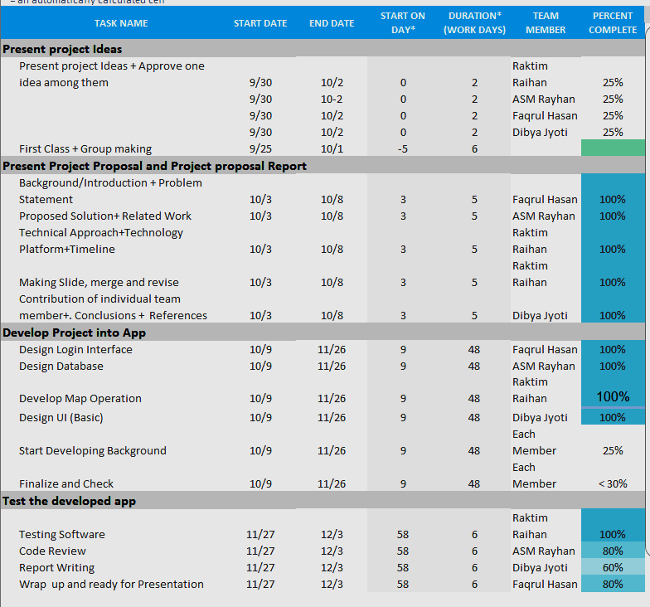

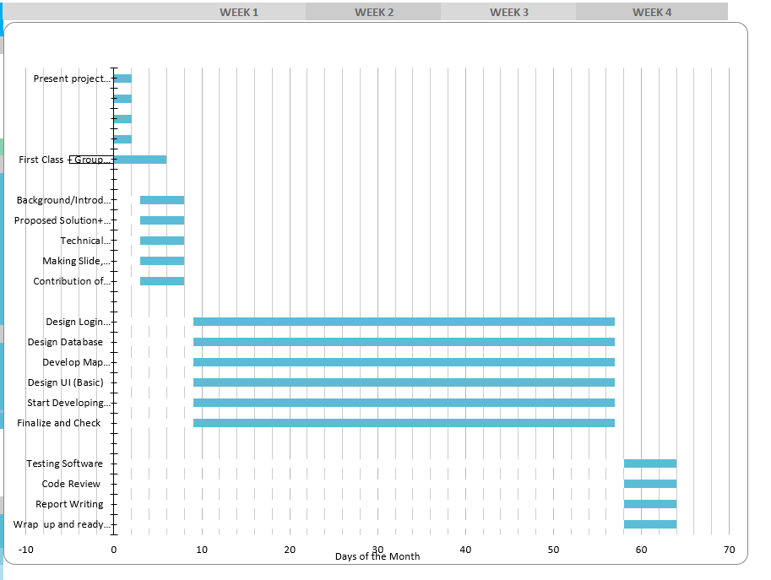

**Contribution of Team member:**

|  |  |  |  |  |  |
| --- | --- | --- | --- | --- | --- |
|  | Project Idea | Design & Report on Proposal | App Building | Testing | Project Report |
| Raktim Rayhan Prova | 25% | 35% | 30% | 30% | 20% |
| A S M Rayhan | 25% | 25% | 20% | 30% | 20% |
| Faqrul Hasan Arif | 25% | 20% | 25% | 20% | 30% |
| Dibya Jyoti Dhar | 25% | 20% | 25% | 20% | 30% |

**Conclusion**:

As we discussed here that parking is the one of the biggest problems in Dhaka City. It costs five million work hours and costs 37,000 crores per year. Illegal parking creates chaos in the street of Dhaka. But, in many apartments or office’s parking space are empty because those aren’t available for everyone. If these parking space can use effectively, it will reduce the amount of illegal parking cases and will economic beneficial for parking owner. It’ll be very effective in Dhaka and other megacity in the other countries.

**Reference:**

* https://www.osac.gov/pages/ContentReportDetails.aspx?cid=21165
* https://www.dhakatribune.com/bangladesh/dhaka/2017/11/11/traffic-dhaka-private-cars/
* https://knoema.com/atlas/Bangladesh/topics/Crime-Statistics
* https://www.thedailystar.net/news-detail-106129
* https://knoema.com/atlas/Bangladesh/topics/Crime-Statistics
* <http://bbs.portal.gov.bd/sites/default/files/files/bbs.portal.gov.bd/page/a1d32f13_8553_44f1_92e6_8ff80a4ff82e/Bangladesh%20%20Statistics-2017.pdf>
* <https://en.prothomalo.com/bangladesh/news/173182/Dhaka-s-traffic-jam-causes-Tk-370b-annual-loss>
* <https://mutuallyhurtingstalemates.wordpress.com/2015/07/31/traffic-jam-in-dhaka-city-causes-and-effects/>
* <https://www.researchgate.net/publication/266059210_Possible_Causes_Solutions_of_Traffic_Jam_and_Their_Impact_on_the_Economy_of_Dhaka_City>